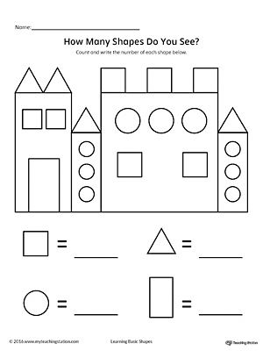
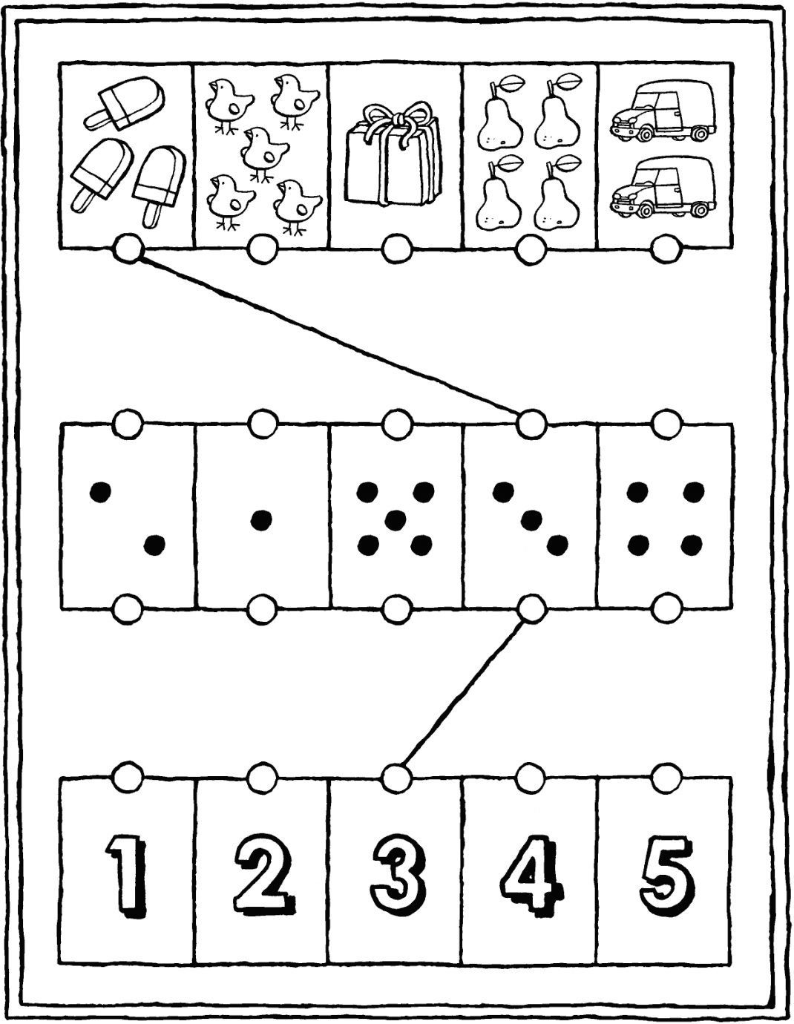https://kiddicoloriage.fr/gepersonaliseerde-kleurprent/?kid=23490
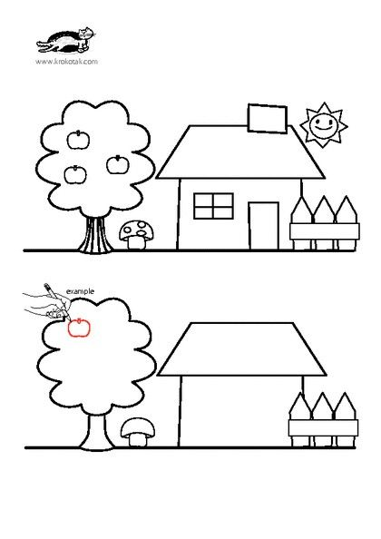
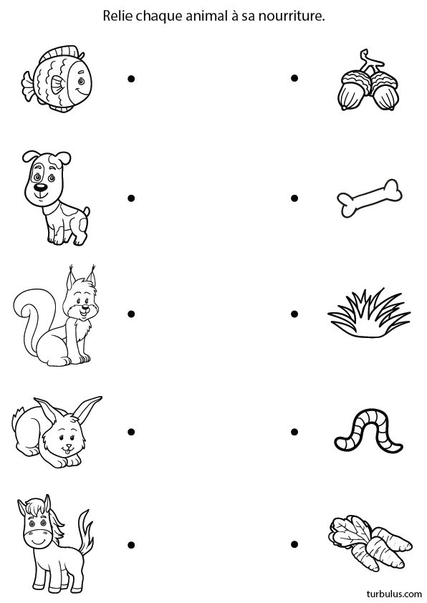https://turbulus.com/jeux-a-imprimer/4-6-ans/483-animaux-et-nourriture

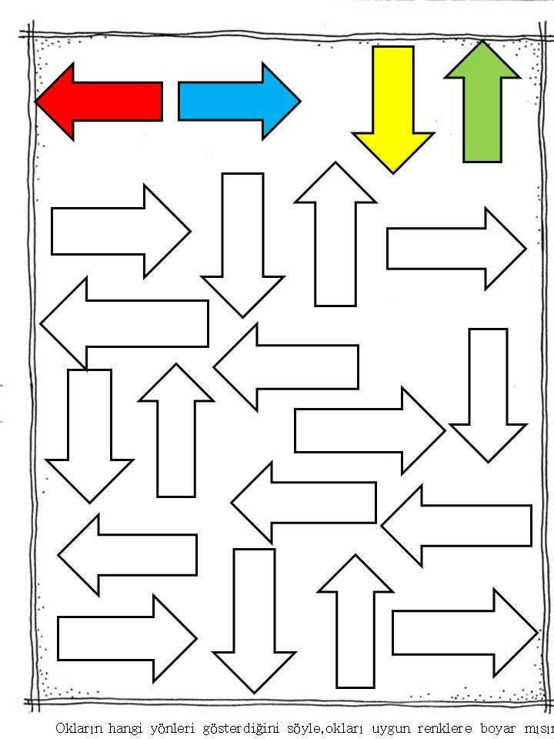
https://i.pinimg.com/originals/6a/36/5b/6a365b3411d51d9ecd784d3f215b26b8.jpg

